**Program Specification for an**

**Informational Website**

**PayWithCrypto**

<https://paywithcryptocurre.wixsite.com/paywithcrypto>

**TravelbyBit Team # 2:**

**Melvin Flores**

**Melvin Chen**

**Jose Bautista**

**Carolina Scudeler**

**Table of Contents**

UPDATES 1

1. Introduction 2

2. Objectives 2

3. Scope 2

4. Site Map 3

5. Page Templates 4

5.1. Header Page 4

5.2. Home Page 4

5.3. Prizes Page 5

5.4. How to Win Page 5

5.5. Where to Spend Page 6

5.6. How to Buy Page 6

5.7. Contact Us Page 7

5.8. Footer Page 7

6. Interface Requirements 9

7. User Characteristics 9

8. Program Limitations / Constraints 9

9. Non-Functional Requirements 9

9.1 Legal Requirements 9

# UPDATES

|  |  |  |  |  |
| --- | --- | --- | --- | --- |
| **Author** | **Version** | **Remarks** | **Status** | **Date** |
| Melvin Flores | Initial Version (version 1.0) | Program Specification - PayWithCrypto v1.0 | Released | 25July2019 |
|  |  |  |  |  |
|  |  |  |  |  |
|  |  |  |  |  |
|  |  |  |  |  |

# 1. Introduction

This document is the Program Specification for a simple informational website, with no transactional data, for the project of TravelbyBit Team # 2. This is the initial draft for the Program Specification, and it will be used for further updates and maintenance of the website.

# 2. Objectives

The aim of this document is to specify the Program Specification of the simple informational website. It is the single point of information, updates and/or maintenance regarding the website. It is basis for agreement between the mentor of TravelbyBit and the mentees of the TravelbyBit Team # 2, with regards to the website to be released and published. Through this document, the workload needed for development, validation and verification will ease. To be specific, this document is going to describe functionality and the constraints of the system which is going to be developed. Therefore, intended reader groups for this Program Specification are TravelbyBit mentor and mentee, potential media influencers and potential investor and sponsors.

# 3. Scope

This project is intended for making use of today’s common technology, a website. Currently, there are lots website providers and website services in the market. Usually they provide lots of extensive features for the website to ease the creation of a website itself. However, we initially chose wix as our website content creator. First, they provide a drag and drop functionality so the website developer does not need to know anything about a website programming language. Template, images and videos are also available. They offer it for free, the downside will be the domain name as it does not reflect ownership of the website, it still carries the wix brand. However, this is a good place to start the website prototype. Also, we can have a paid subscription to wix anytime to own the domain name. By using wix, this project will remove the requirement for a website developer to know a web programming language. It also provides ease of use and update of the website for the web developer.

# 4. Site Map

This is the diagram of the informational website which shows the ‘tree’ type, hierarchical structure of the website pages. Flow of the pages is as easy and as simple as possible. The website is designed as a one-page website so that users will not leave the page, and they can scroll down from top to bottom. This is a laptop, tablet and mobile friendly site.

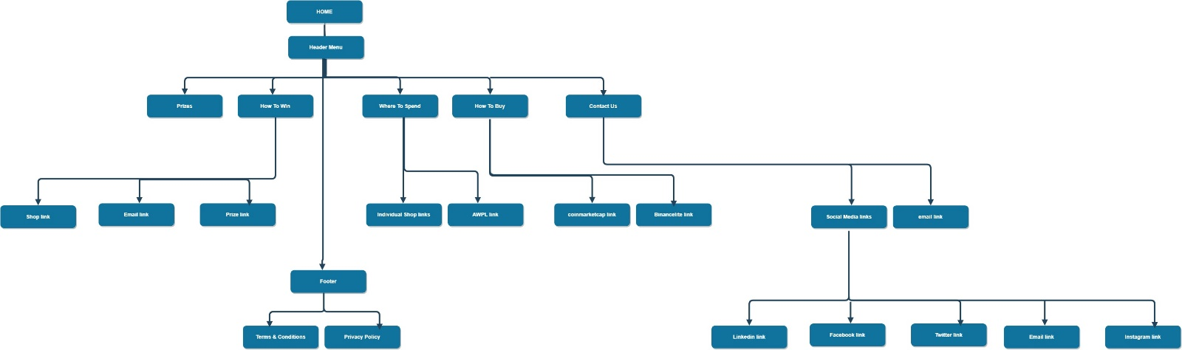

# 5. Page Templates

This section gives the page templates as a specific layout of information. We have the typical pages like ‘Home’ page and ‘Contact Us’ page. Most pages will be 'static' in the sense that they don't react to user actions. The exceptions here are usually the menu item, buttons, and icons. Description for each page can be found below;

## 5.1. Header Page

The Header Page shows the menu of the different pages. If the user selects page in the menu, they will be brought to the starting content of that page. This menu will be fixed in the upper part of screen in whatever page the user is, for ease of Navigation. User can transfer from one page to another, as he desires.



## 5.2. Home Page

This is the main page of our informational website. From here, user can get an overview of our page. An action is requested from the user, and the button ‘Play Lucky Draw’ will be clicked. The event will transfer you to the ‘How To Win’ page.

The Home page also displays our sponsors. When they click a sponsor, they will be led to the Sponsor’s website.

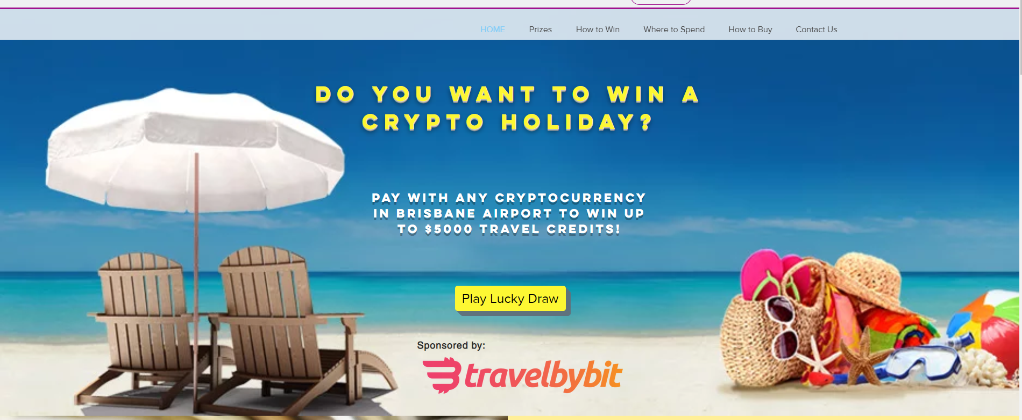

## 5.3. Prizes Page

This is the prize page of our informational website. From here, contestants/users are informed of the Minor and the Jackpot prize, as well as the frequency and date of the draw.

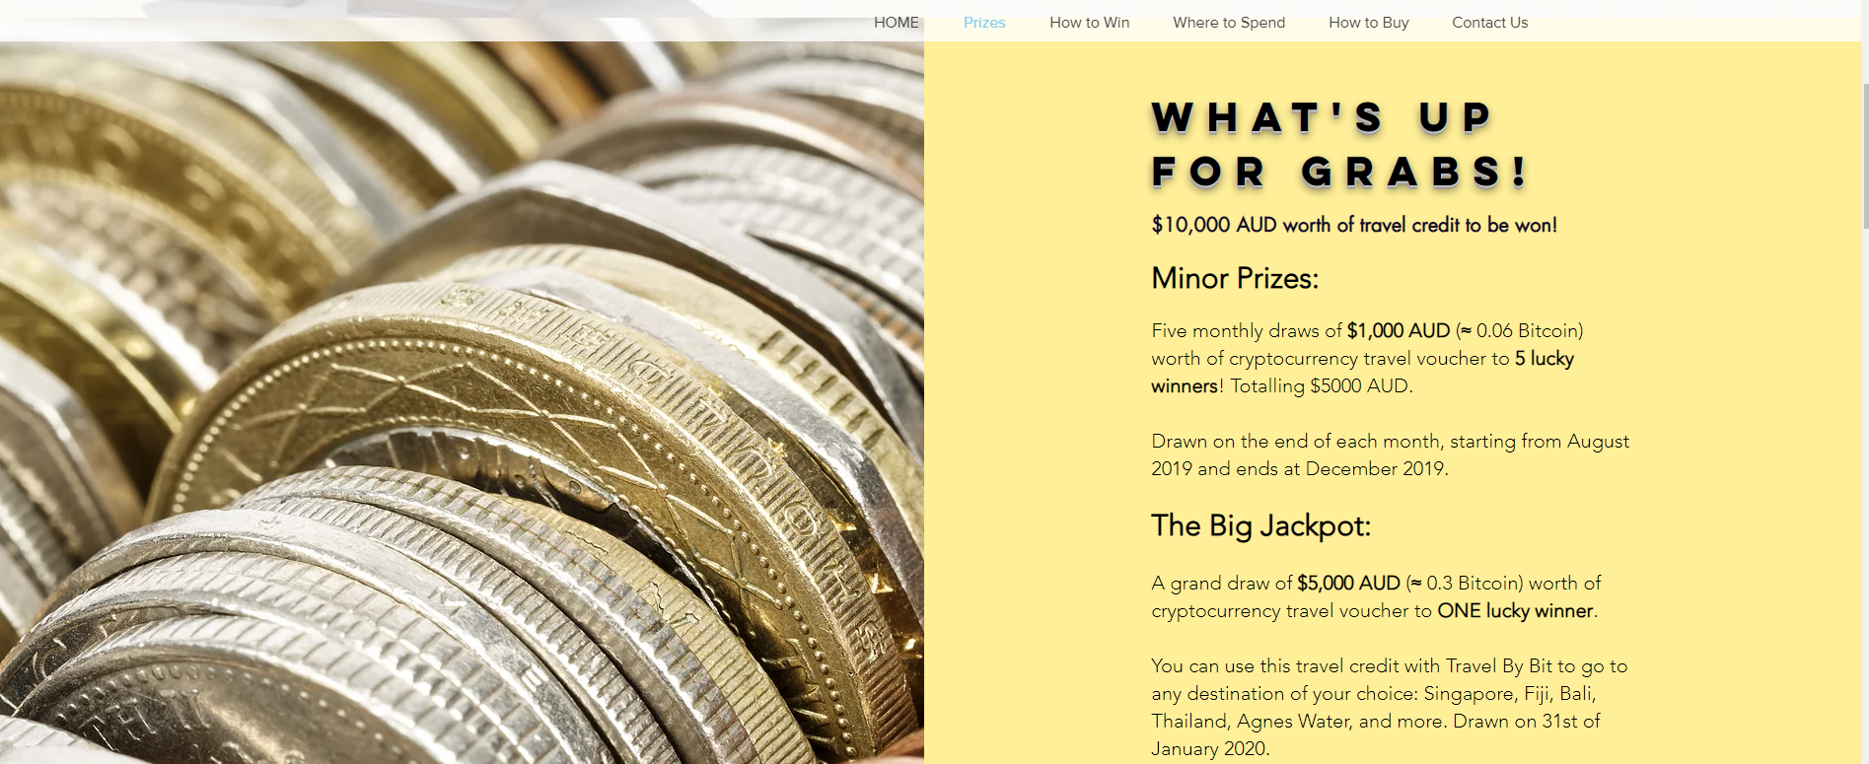

## 

## 5.4. How to Win Page

This is the mechanics page on how to join the draw. It outlines three steps. Each step also has a button in the bottom.

First step has the ‘Shops’ button, which transfers the user to ‘Where to Spend’ page.

Second step has the ‘email’ link and ‘Submit’ button, which transfers the user to his email application and defaults to a sender with the contestants/users email address, a recipient of ‘paywithcryptocurrency@gmail.com’, and a subject of ‘paywithcryptocurrency’. In this email, contestant/user will attach his proof of cryptocurrency transaction and hit the send button.

Third step has the ‘Prizes’ button, which transfers the user to ‘Prizes’ page.

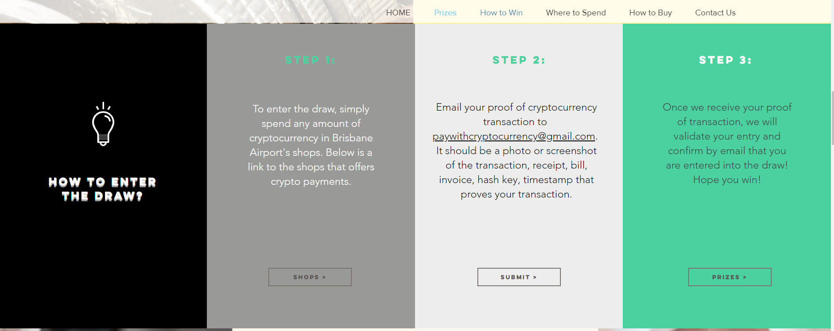

## 5.5. Where to Spend Page

This page shows the Brisbane International and Domestic Airport shops as well as retail shops. Each shop is clickable and will bring you to the shop’s website. It has a ‘More Info’ button in the bottom which brings the user to the AWPL Queensland Brisbane website.

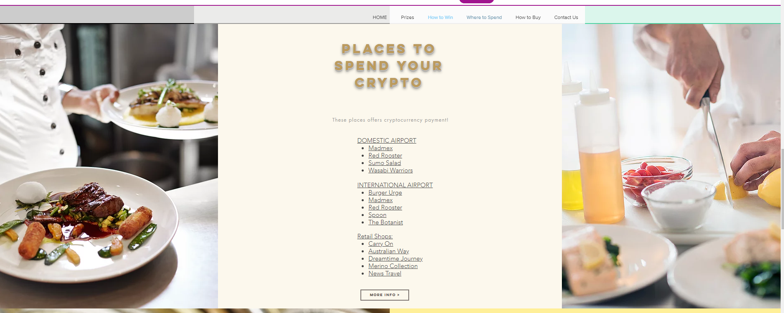

## 5.6. How to Buy Page

This page shows the information on how to buy a cryptocurrency. It has a link to the different types of cryptocurrency which brings the user to the ‘coinmarketcap’ website. It has a ‘Buy Cryptocurrency’ button in the bottom which brings the user to the ‘BinanceLite’ website.

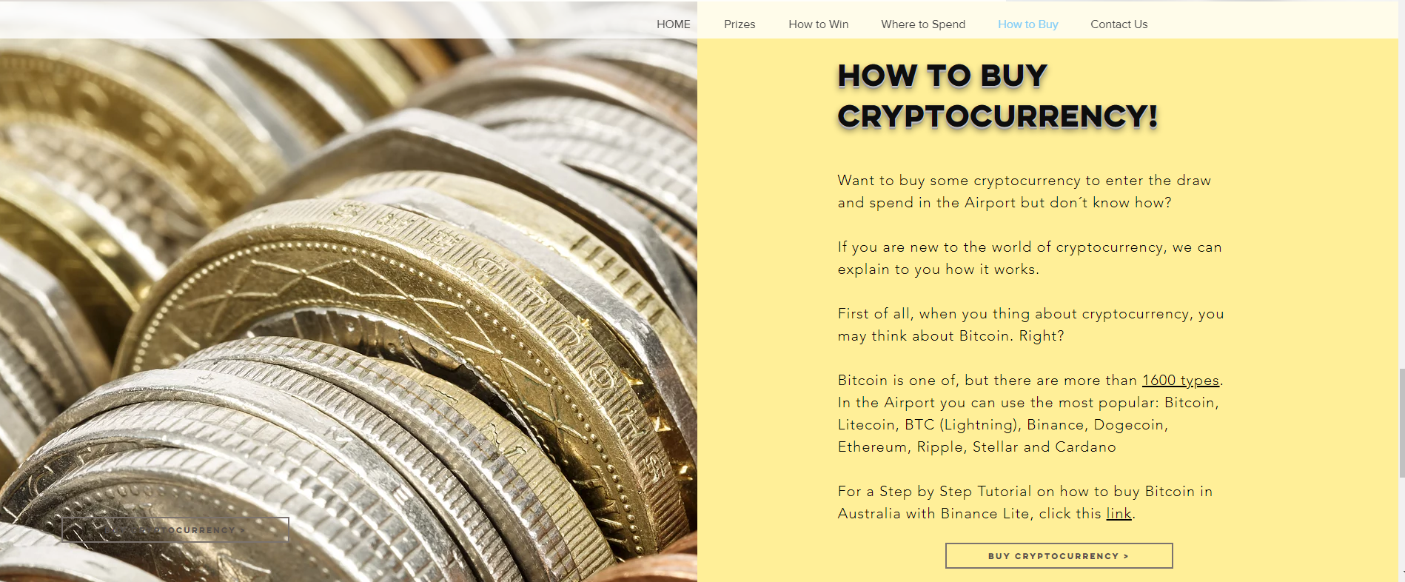

## 5.7. Contact Us Page

This page shows the physical address in Queensland. There is an e-mail type format where the user can contact us, he can write his name, email, subject, message and hit the ‘send’ button. The message will be received at ‘paywithcryptocurrency@gmail.com’. There are also Social Media icons in the bottom of the page. Initially, clicking an icon creates an event which brings the user to social media site for each of the TravelbyBit Team # 2 own social media site: LinkedIn – Mr. Flores, Facebook – Carolina, Twitter – Mr. Chen, Gmail – Jose and Instagram- Mr. Chen.

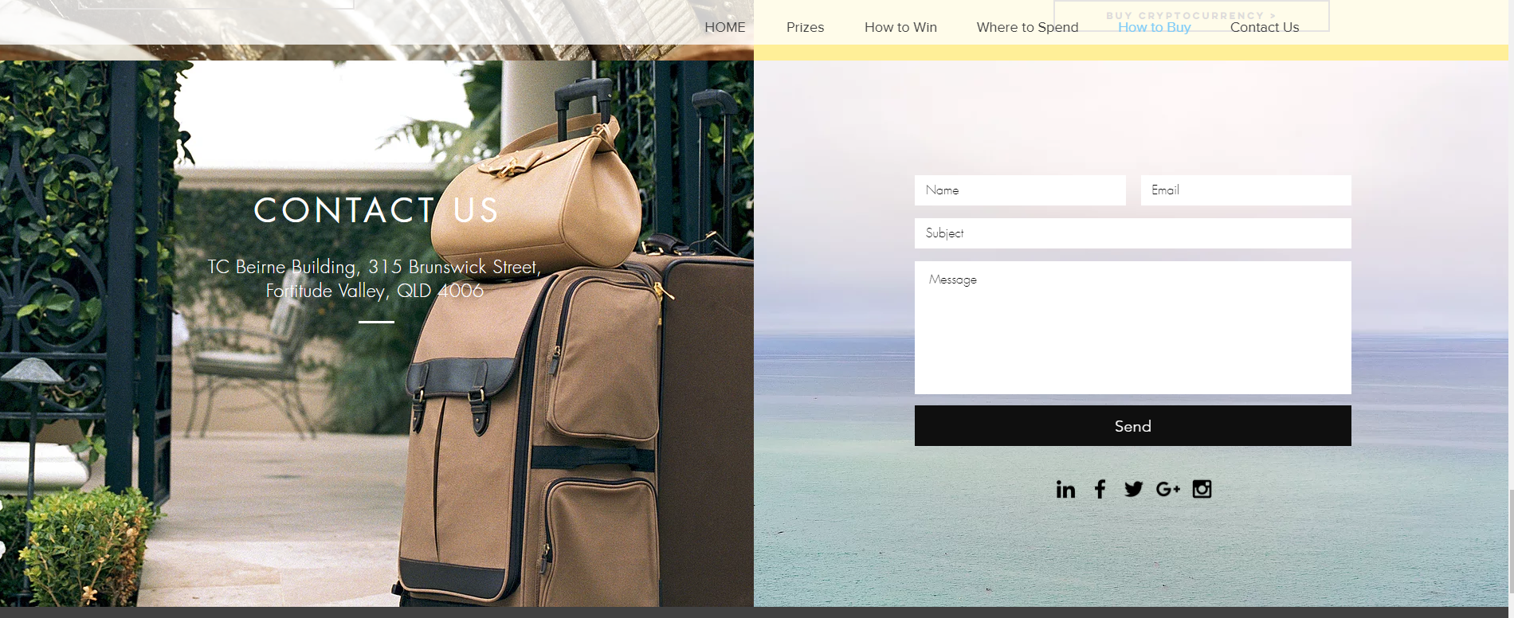

## 5.8. Footer Page

The Footer Page shows the Privacy Policy and the Terms & Condition. If clicked, it will open up to its page. Initial and current contents can be seen on the screen shots below.



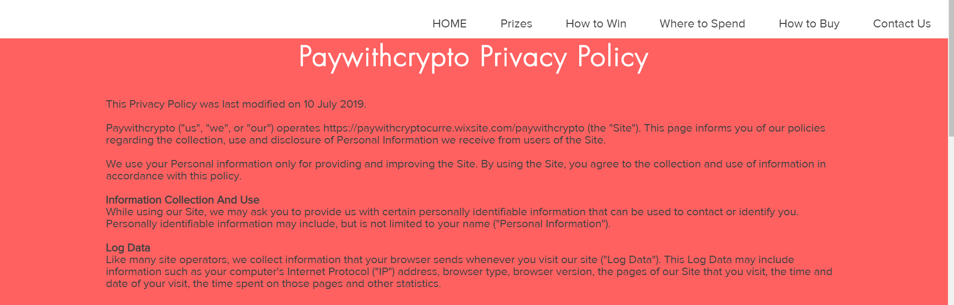

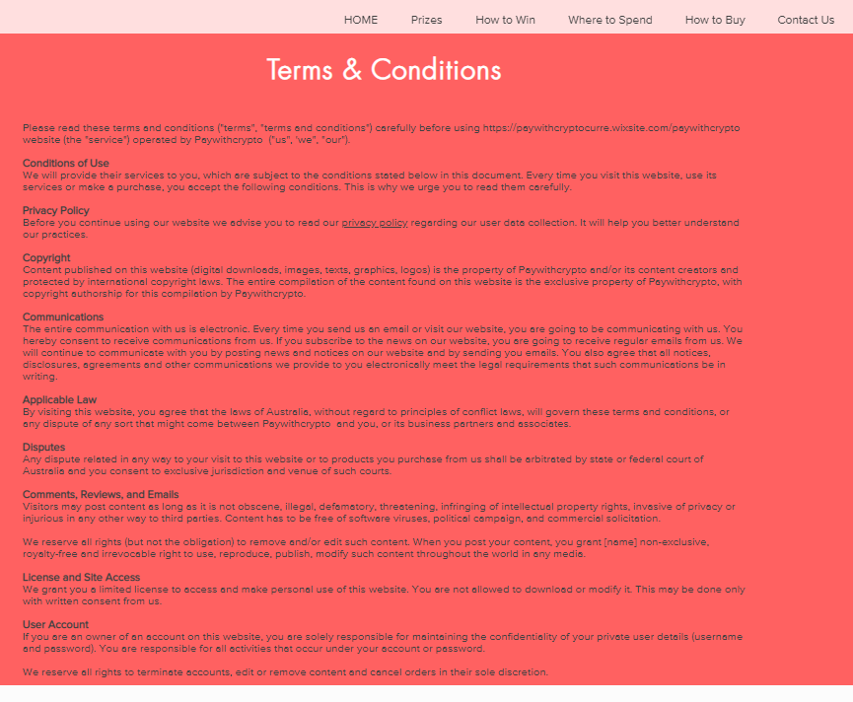

# 6. Interface Requirements

The informational website can be viewed and accessed via laptop, tablet or mobile devices. The user can visit the site at <https://paywithcryptocurre.wixsite.com/paywithcrypto>.

# 7. User Characteristics

Users of this informational website will mainly be mentor and mentee, potential media influencers, potential investor and sponsors, and most importantly are the contestants/users of the website. Since it is reasonable to assume that an average user has common knowledge about functionalities and usage of a website, we assume that our users will already be informed about basic functionality of this website. The only clear documentation and tutorials about this website is this document itself.

# 8. Program Limitations / Constraints

Our website is an informational website only. It does not perform any transactions. All user information and data like proof of cryptocurrency transaction is initially stored in the paywithcrypto gmail, [paywithcryptocurrency@gmail.com](mailto:paywithcryptocurrency@gmail.com). Password is initially known only by the four members of the TravelbyBit Team # 2: Mr. Flores, Carolina, Twitter, Mr. Chen and Jose. This is also true to the wix site which created and managed the site, <https://paywithcryptocurre.wixsite.com/paywithcrypto>.

For the purpose of creating a website prototype, we used wix, which is free. However, our website is owned by wix, as we have not paid any subscription for ownership. We have also not paid for any website domain name.

# 9. Non-Functional Requirements

## 9.1 Legal Requirements

The images and videos used in the website, contents of the terms & conditions, contents of the privacy policy, and use of business/corporate icons needs to be taken care of TravelbyBit mentor as soon as this site goes live. For now, I assume this is acceptable for Academic purpose.

If the user sends an entry, he agrees to the contents of the terms & conditions.